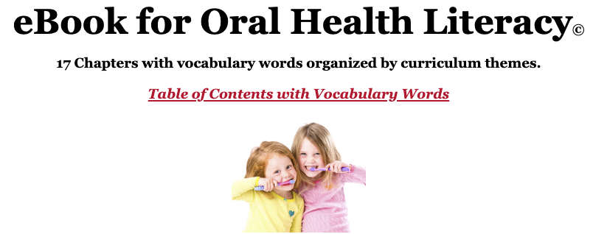
Welcome!
We are promoting our health literacy and health education materials from Miami University which are designed and directed by
Valerie A. Ubbes, PhD, MCHES
ubbesva@miamioh.edu
513-529-2736

Please use this link to access our featured health literacy material:
The eBook for Oral Health Literacy© Curriculum
https://dlp.lib.miamioh.edu/ebook/index.html

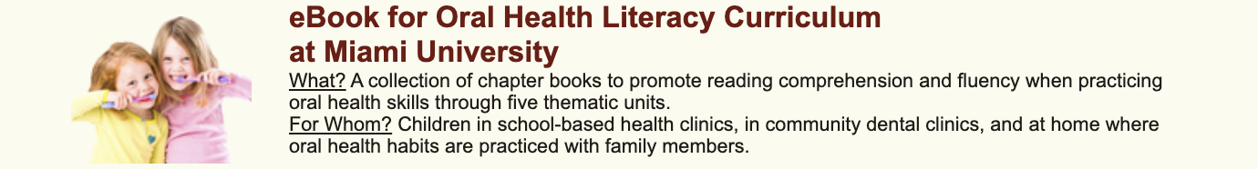

Please use this link for our overall health education website:
Digital Literacy Partnership at Miami University
http://dlp.lib.miamioh.edu

We are also on FaceBook, Instagram, and Pinterest.

