Join our “Reading for a Healthy Smile” Campaign!

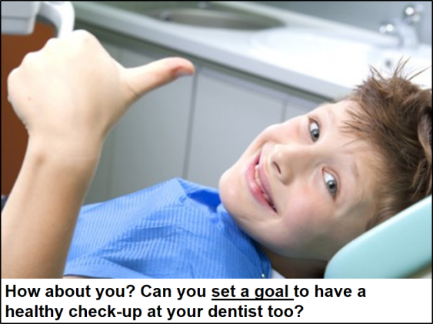

Our eBook for Oral Health Literacy© is a free, online curriculum of picture stories showing children practicing oral health habits with family, friends, and health professionals. Each photograph is supported by written and oral narratives to promote healthy habits for brushing and flossing teeth, getting a dental check-up, and selecting fresh foods and beverages for oral health.
The goal of our “Reading for a Healthy Smile” campaign is to boost literacy and oral health skills through an interactive eBook that narrates chapters of one minute duration to children. We have 17 chapters, 20 vocabulary spotlights, 5 themes, and 4 educational newsletters for teachers, parents, and dentists to help support health literacy skill development with children. Children can use digital devices to access the stories in academic classrooms, at home, or while they wait for their dental check-ups in a clinic.

Bookmarks with a digital QR code are handed out to children so they can link with different chapters to read and learn how to set goals and make decisions for a healthy smile. Research indicates that dental cavities, also known as tooth infections, are the most common chronic disease in children. Our own research shows that students with the lowest literacy skills also report doing fewer health behaviors (e.g., regular dental check-ups, brushing and flossing teeth, and selecting fresh foods and healthy beverages).

Please join and share our “Reading for a Healthy Smile” campaign to promote literacy and health behaviors through our eBook for Oral Health Literacy©!

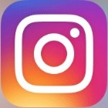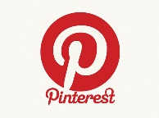

Go to eBookforOralHealthLiteracyCurriculum on social media. Also access all 17 chapters of the eBook on our Digital Literacy Partnership Website at https://dlp.lib.miamioh.edu

